Session 1

1. Working with Lambda & Lambda Block

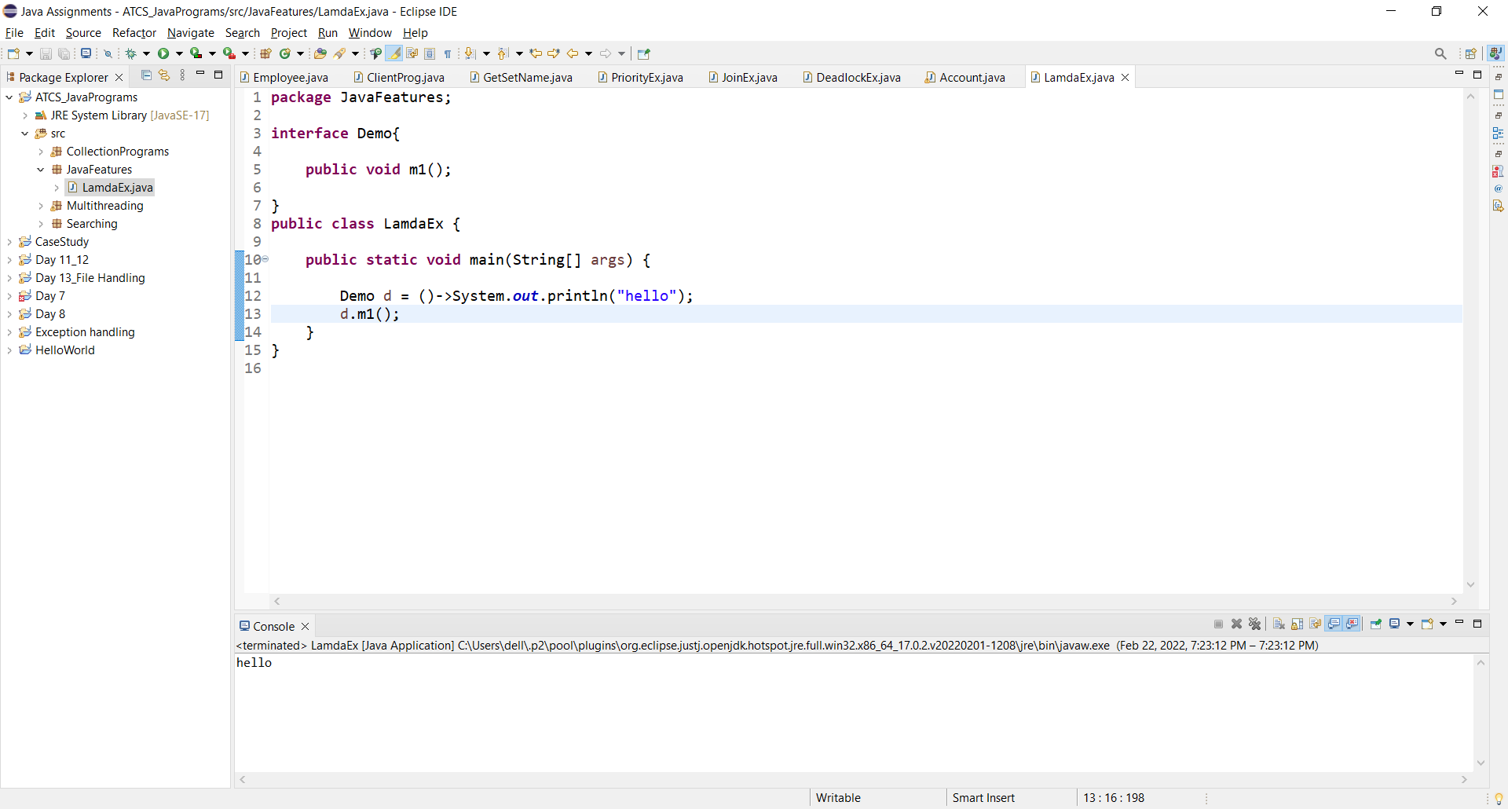

1. Create a Runnable interface and apply lamda expression.

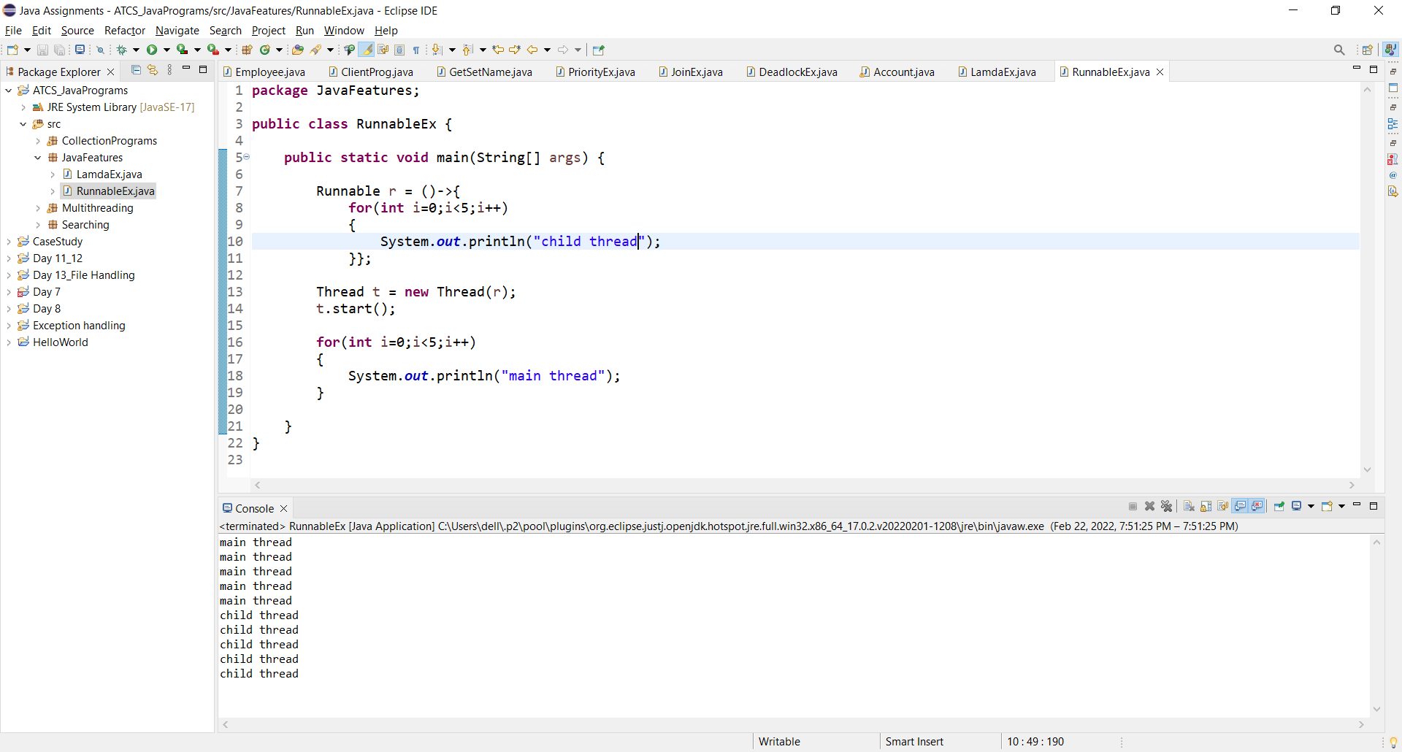

1. Create a class SquareRoot apply lamda expreesions.

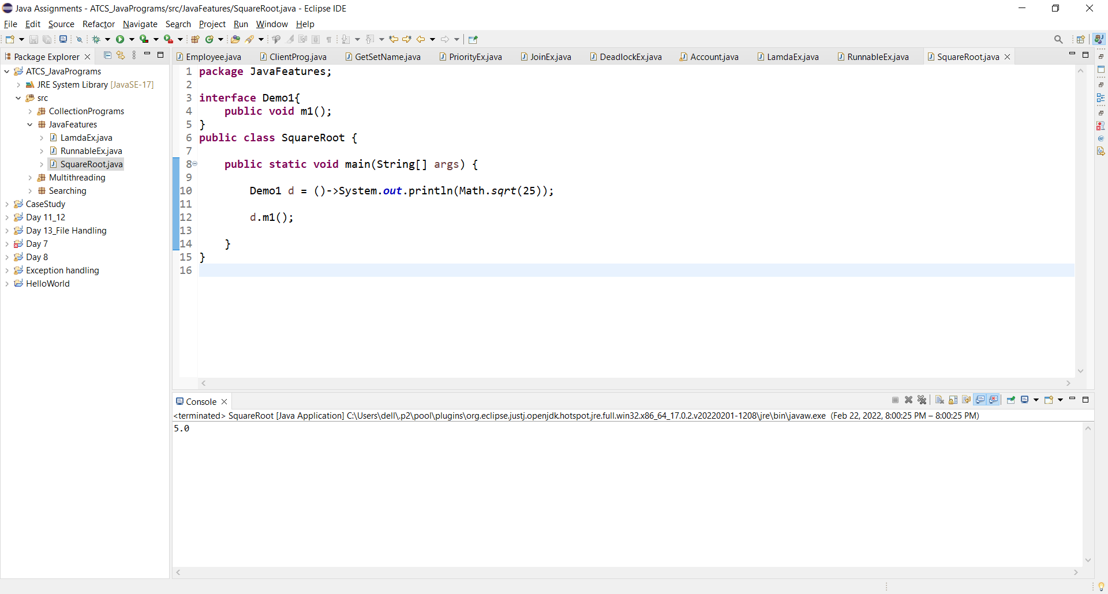

1. Create a class with addition method with parameters.

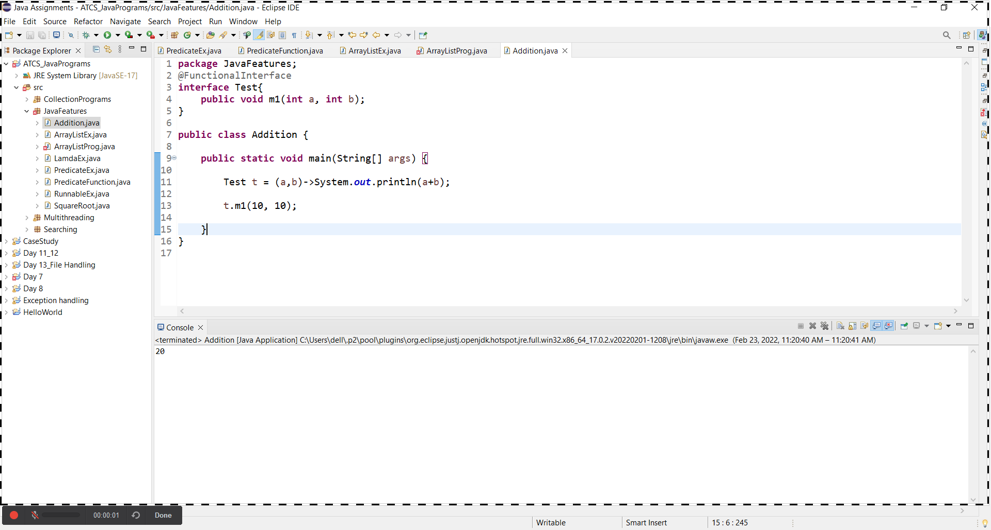

1. Create a ArrayList class add values apply lamda expression.

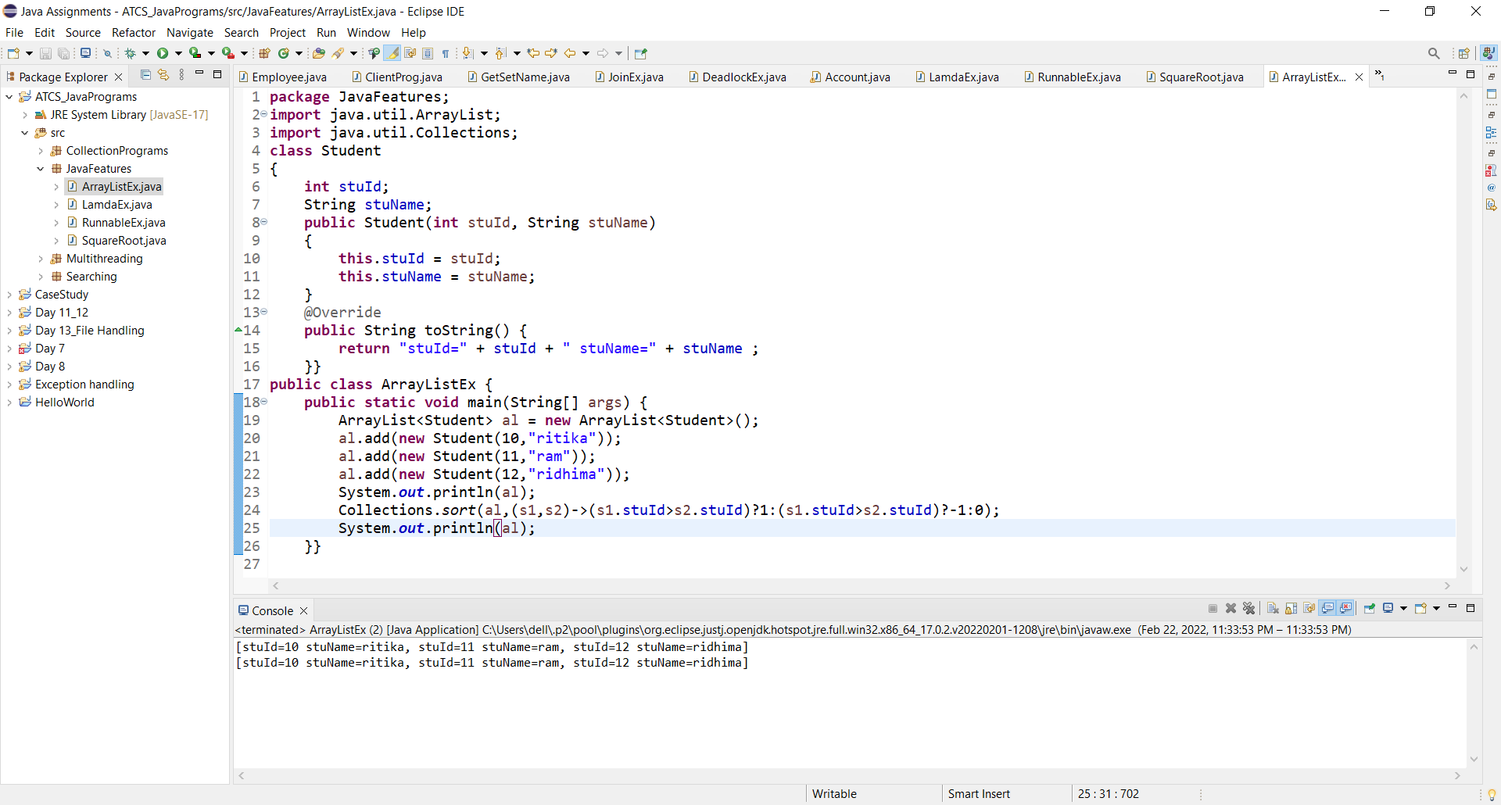

**Session 2**

1. Take predicate functional interface test given value even number or not.

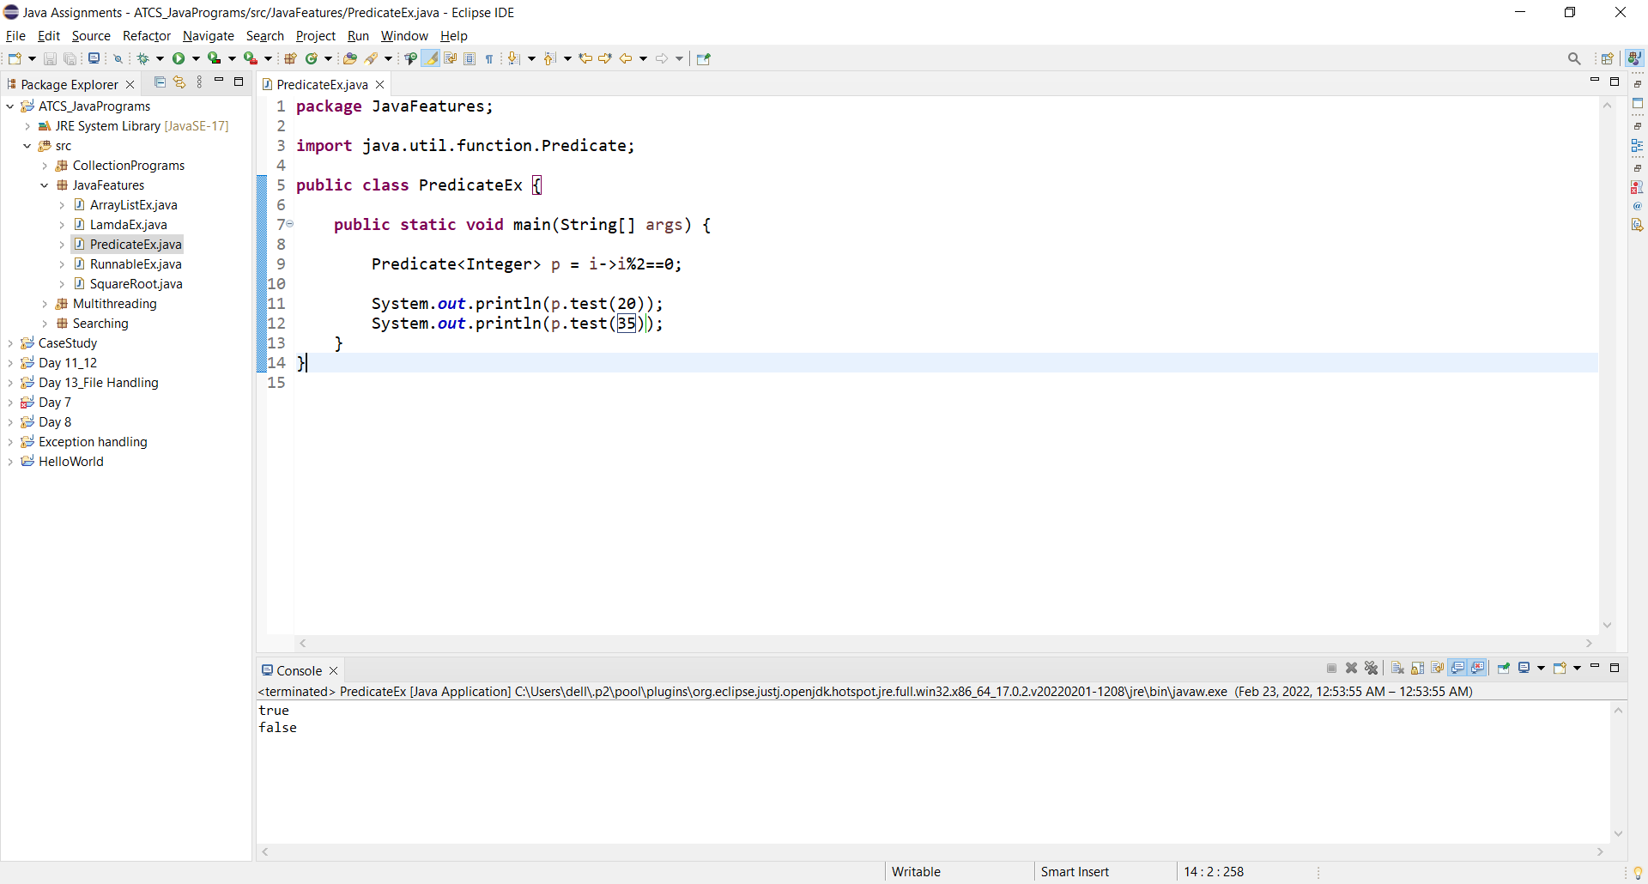

1. Take predicate functional interface test length of the given name is greater than 6 or not?

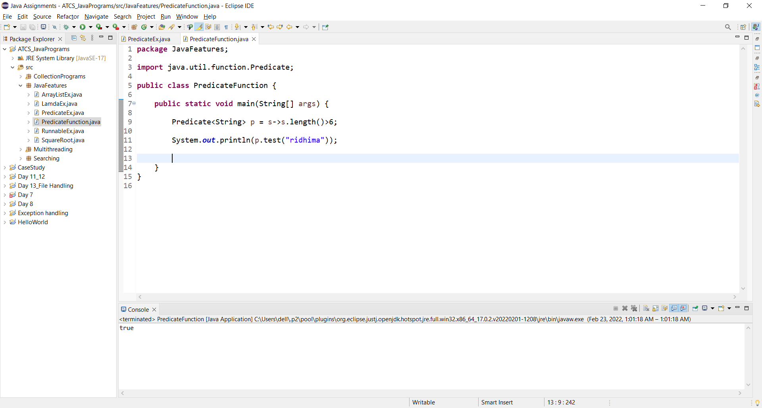

1. Create a employee class with ArrayList class add key value pair name,salary, findout salary>7000?

